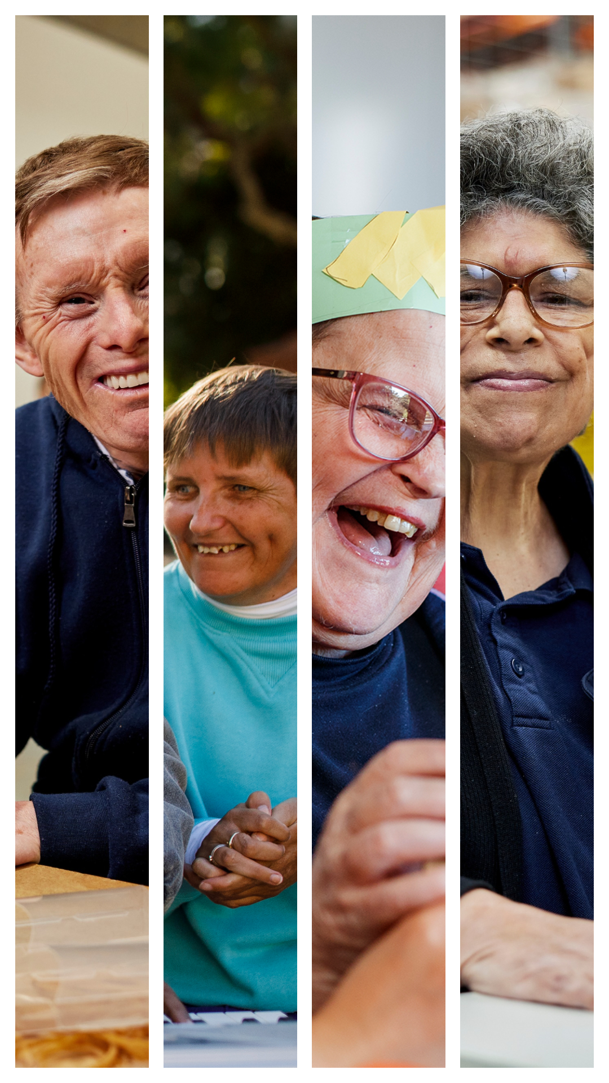
Joint Submission to the Minister for Aged Care

The Hon Anika Wells MP

Submission:
Urgent Recommendations for the Disability Support for Older Australians Program

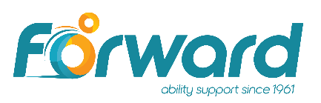
Executive Summary
We request the Minister for Aged Care:
- urgently accept the NDIS Review’s recommendation to move DSOA to the NDIS (Action 2.12)
- immediately cease moving DSOA participants into aged care
- reverse the decision to transition DSOA participants who live at home and access less than $50,000 per year in funded supports out of the DSOA Program
- introduce Specialist Disability Accommodation (SDA) funding for DSOA participants, based on NDIS pricing.
Our organisations provide support to 30% of DSOA participants.
This submission shows that DSOA’s funding model does not reflect the range of support needed by people with life-long disabilities, particularly SDA.
Current Issues
DSOA does not fulfill COAG’s commitment that people with disabilities aged over 65 at the time of the NDIS rollout would not be worse off.
The two different systems for people with similar needs have led to significant inequity, inefficiency, and unfairness.
DSOA participants are being moved prematurely into aged care, based on inaccurate or obsolete ICAN assessments.
- People with disabilities are not receiving the correct care and support in aged care services, resulting in poorer quality of life and avoidable hospitalisations.
- Our organisations can provide recent examples.
This Program and its predecessor, the Continuity of Support (CoS) program, have never properly funded participants’ accommodation and support costs, based on their clinical and functional support needs.
- Service providers have subsidised participants’ accommodation costs since the creation of the CoS program.
- DSOA’s funding model has not kept pace with the closure of state disability accommodation and the evolution of modern accommodation for people with disabilities.
DSOA participants should be urgently moved to the NDIS, so they can access care and support from a system designed to support people with disabilities.
Recommendations
1. Urgently accept the NDIS Review’s recommendation to move DSOA participants to the NDIS
Action 2.12 from the NDIS Review Final Report states:
‘The Australian Government should implement legislative, or process change to allow access to the NDIS for Disability Support for Older Australians Program’
The Federal Government should move DSOA participants to the NDIS as soon as practicable.
2. Immediately cease moving DSOA participants into aged care
We request that all DSOA participants immediately cease moving into aged care until the future of the Program is confirmed.
3. Reverse the decision to transition some DSOA participants out of the DSOA Program
All DSOA participants should have the opportunity to move to the NDIS if they wish.
4. Introduce Specialist Disability Accommodation funding for DSOA participants, based on NDIS pricing
All DSOA participants should have access to modern SDA accommodation.
This funding can be provided while decisions are being made on the future of the DSOA Program.
Funding should be based on the NDIS SDA Pricing Guide, as the price setter for accessible accommodation.

Continuity of Support – equity with the NDIS
The former Council of Australian Governments committed to providing continuity of support for older Australians who were receiving state-managed specialist disability services but were ineligible for the NDIS.
The Continuity of Support (CoS) program was established to ensure that people aged 65+ who had been receiving state-managed specialist disability services:
were not disadvantaged in the transition to the NDIS
achieved similar outcomes to state specialist disability services.
Due to the pace and challenge of implementing the NDIS, the CoS’ funding model never received the necessary attention to ensure it met the needs of participants.
The CoS program transitioned to the DSOA program on 1 July 2021.
DSOA is intended to meet the Australian Government's commitment to provide:
funding for disability services broadly aligned with NDIS prices
support for DSOA clients with complex needs to continue living at home or in supported accommodation as their needs change.
CoS and DSOA timeline
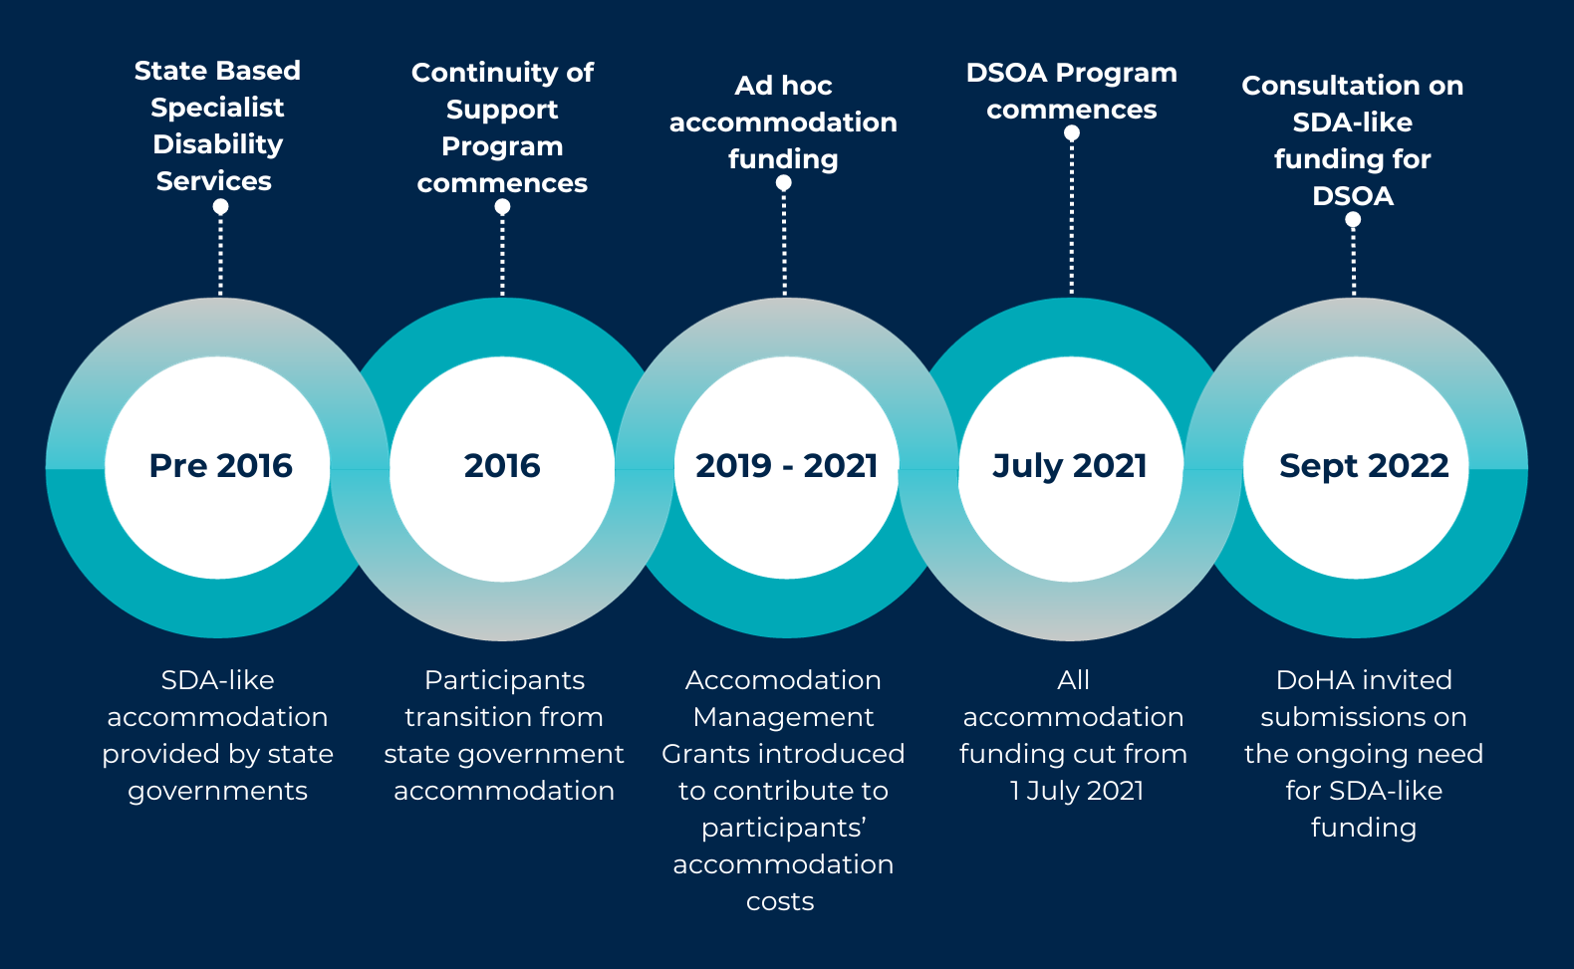

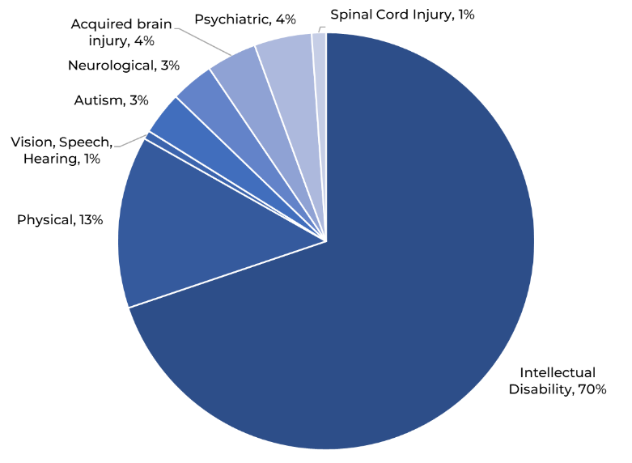
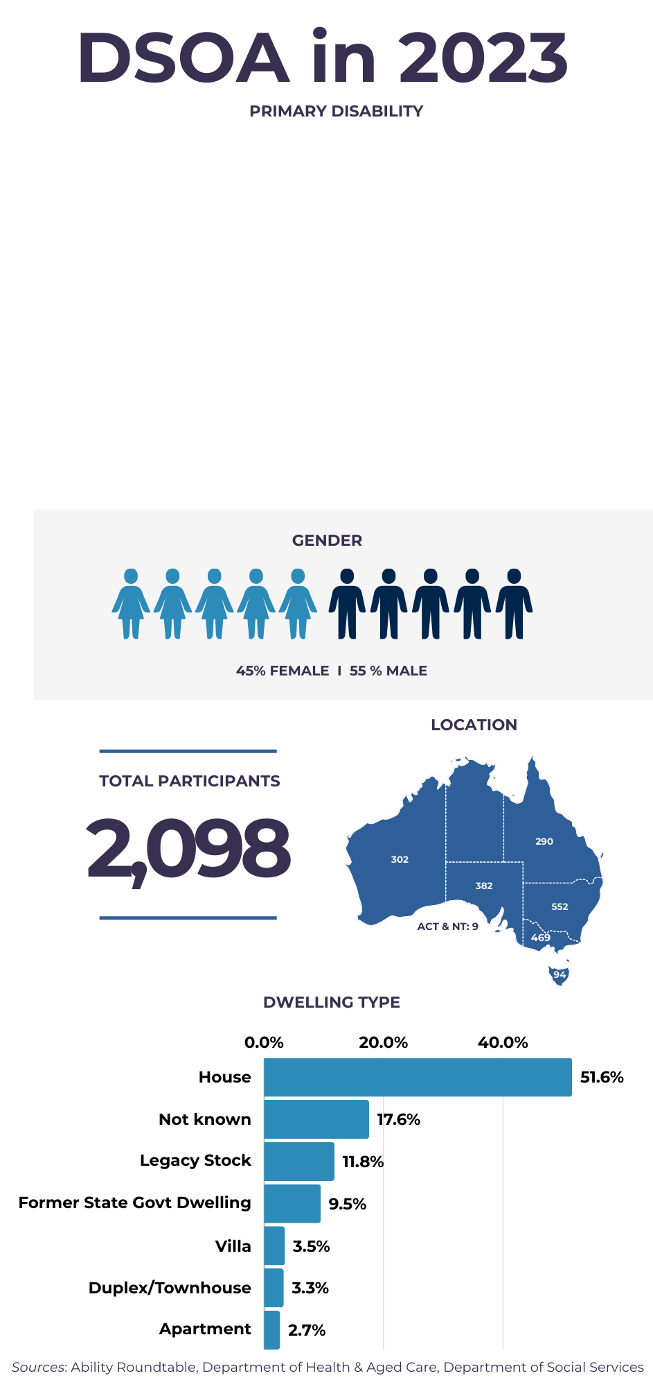
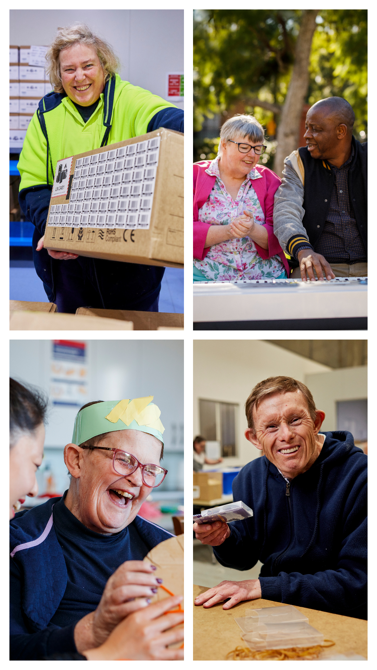
A place of one’s own after a lifetime without choice
Before 2016, most CoS participants lived in state disability service accommodation, where many had lived since they were children or young adults.
Many had never had the chance to choose where they lived or who they lived with.
The Disability Royal Commission highlighted that:
‘People with disability have a fundamental human right to live in suitable housing and be connected to the community.
They should be able to choose where they live, with whom they live, how they live, and who provides their support for daily living and community participation.’
Michael’s Story
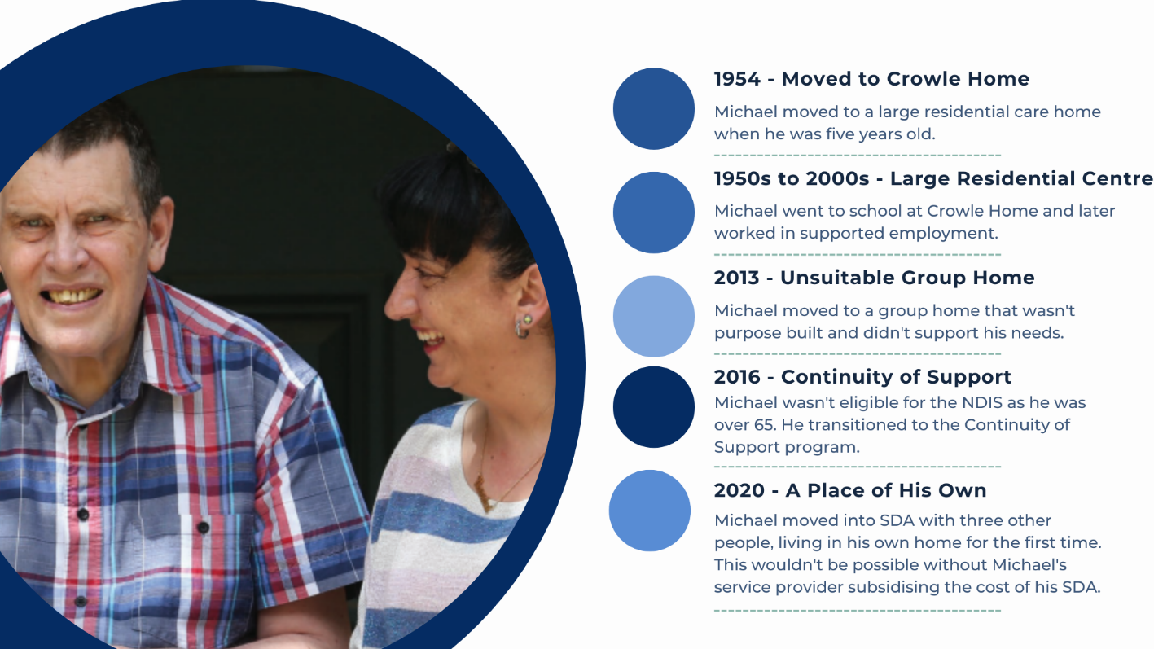
*Michael’s name has been changed to protect his privacy.
DSOA does not fund equitable accommodation and support
DSOA participants are worse off compared to NDIS participants with similar needs

Service providers subsidise participants’ SDA to protect their quality of life

SDA funding is a necessary part of DSOA’s funding model

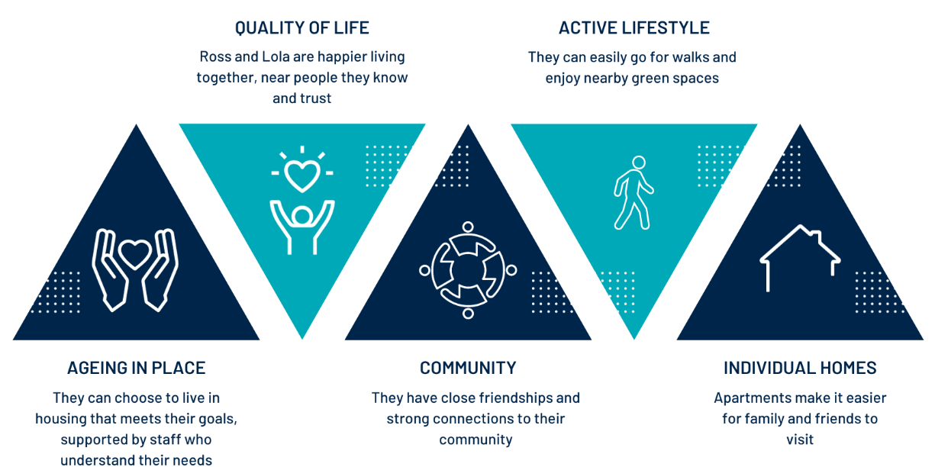
Access to SDA has changed Ross and Lola’s lives
SDA is a reasonable and necessary part of DSOA funding
We have projected the cost and demand for progressively moving DSOA participants into SDA accommodation over the next 10 years, based on data from the Ability Roundtable, the Department of Health and Aged Care and the Department of Social Services.
Projected Cost
The following table outlines the projected cost of providing SDA to:
participants who receive Individual Support Plans in 2024
an additional 10% of participants per year from 2025 – 2033.

 | 2024-25 | 2025-26 | 2026-27 | 2027-28 | 2024-33
SDA Funding ($M) | $18.86 | $20.34 | $19.67 | $19.79 | $152.76
Key Points
All DSOA participants meet the NDIS’ SDA eligibility requirements.
As DSOA participants leave the program (to aged care or death), the cost of SDA accommodation will decrease significantly over the next 10 years.
The cost of SDA increases in 2025-26 due to participants moving from:
- unregistered SDA-like accommodation to New Builds
- Legacy and Existing Stock to New Builds.

Projected Demand
The following chart outlines the:
annual projected cost of SDA over the next 10 years
the number of DSOA participants by accommodation type.
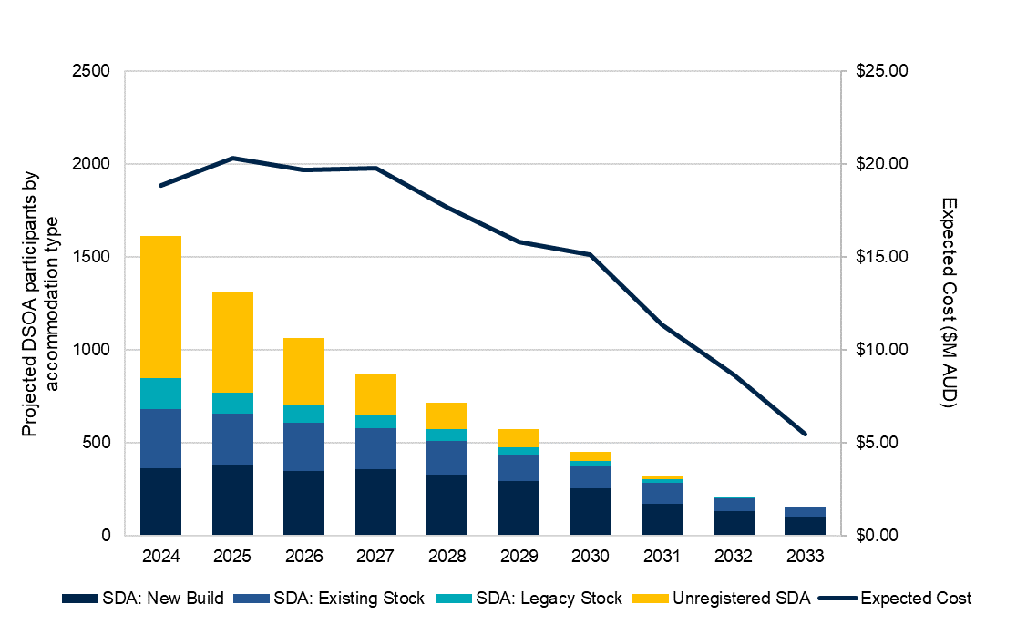
Key Points
DSOA participants will progressively move from legacy or existing accommodation into new builds as more modern accessible accommodation becomes available.
We expect almost all participants to be living in registered SDA (predominantly existing or new builds) within five years.

Low vs High Demand
We projected the cost of low and high demand for SDA.
Even with a much higher uptake of SDA, the cost to the Australian Government is reasonable over the next 10 years.

 | 2024-25 | 2025-26 | 2026-27 | 2027-28 | 2024-33
Low Uptake Scenario ($M) | $16.80 | $14.15 | $13.64 | $12.65 | $97.49
Central Scenario ($M) | $18.86 | $20.34 | $19.67 | $19.79 | $152.76
High Uptake Scenario ($M) | $31.05 | $33.14 | $34.52 | $33.12 | $222.73

Projection Assumptions
 | Low SDA Uptake | Central Scenario | High SDA Uptake
Exit rate | 5% per year | 2.3% per year | 1% per year
Transition from legacy accommodation to new builds | 5% of 2023 population per year | 10% of 2023 population per year | 20% of 2023 population per year
Transition from existing accommodation to new builds | 1.5% per year | 3.2% per year | 6.5% per year
Transition to registered SDA | 5% of 2023 DSOA participants per year (over 20 years) | 10% of 2023 DSOA participants per year (over 10 years) | 20% of 2023 DSOA participants per year (over 5 years)
Background
Ability Roundtable Data
Key data used to determine the demographic profile of DSOA participants and to model the projected costs of SDA for DSOA participants has been drawn from the Ability Roundtable. The Ability Roundtable is a disability service provider benchmarking group operating since 2013. Data used for the modelling is drawn from the Roundtable's FY21-22 Supported Independent Living/shared accommodation benchmarking data, which holds dwelling and client data for 33% of the NDIS market.
In addition to these clients, the Ability Roundtable also holds data for 601 DSOA participants, including the dwellings in which they live. Based on information provided by the Department of Health and Aged Care, this represents 29% of all DSOA participants and approximately 50% of DSOA participants who live in SIL/shared accommodation settings.
Ability Roundtable captures granular data down to the individual client and dwelling. Client characteristics captured include age, gender, disability and funding level. Dwelling characteristics captured include dwelling type, number of bedrooms, SDA classification (if known), postcode and ownership.
All data has been used with permission.

Delivery of SDA
There are two ways that DSOA participants receive support services and access accommodation for DSOA participants:
- Service providers deliver both support services and SDA to DSOA clients, using SDA assets that service providers’ source.
This accommodation is often not fit for purpose and does not meet participants’ needs. In many cases, this accommodation is not enrolled as SDA as it is not compliant with NDIS standards.
- Service providers deliver services and assist their DSOA clients to choose appropriate accommodation services from an SDA provider.
Consistent with Australian Government policy and sector best practice, many service providers have separated accommodation and service provision for their DSOA clients.
This approach allows DSOA clients to have choice and control over their lives, so they can choose their service provider without potentially affecting the security of their accommodation.
Evolution of Disability Accommodation
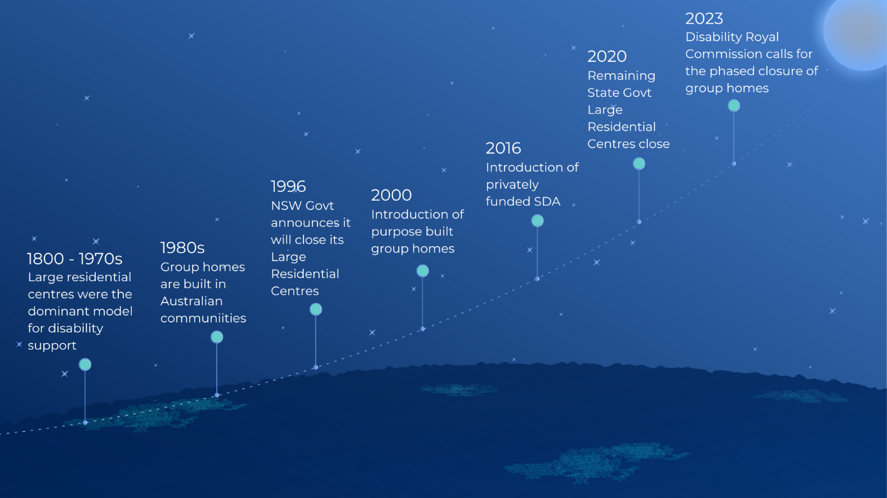

Service providers cannot keep filling DSOA’s funding gaps
DSOA participants cannot live in accessible housing unless their service provider subsidises it.
Service providers have been funding the cost of SDA for their DSOA clients, often since their transition from state government accommodation.
These organisations often have long-term relationships with their DSOA clients and are passionate about providing high quality support that helps them meet their goals.
They have managed significant funding uncertainty during the transition from state government support to CoS and then DSOA.
The current situation is not acceptable.
DSOA Accommodation Management Grants were cut in 2021
The Department of Health and Ageing previously offered Accommodation Management Grants (2019 – 2021) as an ad hoc contribution towards the cost of supporting eligible clients living in residential supported accommodation settings.
Service providers could not rely on this funding to cover their clients’ accommodation costs.
From 1 July 2021, the Department cut this funding but did not make this clear to service providers, SDA providers, or announce this publicly.
DSOA participants want to live in the community
"I like who I live with, I like the location and living with others I already know."
Nicky, DSOA participant in Ryde NSW
DSOA participants living in SDA demonstrate the benefits of ‘ageing in place’:
Funding SDA means DSOA participants can continue to live with the people they have chosen to live with in accommodation that best meets their needs.
- These relationships can span decades.
- In many cases, this is the only family that participants have known.
They are actively engaged in their communities and have strong social connections.
They have a better quality of life, receiving tailored support in accommodation that meets their needs.
Co-Signing Organisations
Ability First Australia
Ability First Australia (Ability First) is one of the largest not for profit strategic alliances between 14 of Australia’s leading disability service providers. With member organisations in all states and territories, Ability First represents the interests of around $2 billion worth of support services to over 92,000 people with disability, their families and carers. Together, our members provide services to over 20%of Australians who currently receive funding for disability services.
Our members have a long and trusted history, having supported people with disability for between 50 and 92 years. Ability First supports its members through policy and government advocacy, knowledge sharing, and developing strategic partnerships with relevant stakeholders.
While Ability First organisations provide innovative and responsive services to meet the needs of people living with a wide range of disabilities, we have a particular interest and deep expertise in working with people with multiple and complex disabilities.
Ability First member organisations include:

Ability WA
Annecto
Aruma
Cara
Carpentaria
CPL
Cootharinga North Queensland
LiveBetter
Montrose
Multicap
Northcott
Novita
Polio Australia
Rocky Bay
Scope Group
St Giles
Yooralla.

Alliance20
Alliance20 brings together some of Australia’s largest disability service providers from across the country to develop initiatives to strengthen the NDIS and deliver better services and outcomes for participants. Our focus is on using our collective scale, and diversity to support the growth and reform needed for the NDIS to be a success for people with disability. We do this by providing a strong provider voice, based on the needs and interests of the people we support, to policy makers and government. We draw on our broad and deep nationwide disability experience to develop and propose practical solutions based on rigorous best practice, consultation and the input of our clients and families.
Many Alliance20 providers support older Australians with disability through the DSOA program and are committed to ensuring that this program properly supports our clients.
Achieve Australia
Achieve Australia (Achieve) is a for-purpose community organisation that has been providing accommodation and services to people with disability since 1952. We champion social inclusion, focusing on the individual needs and lives of the people we support. Achieve delivers expert disability support services to people with complex disability across greater Sydney and in the Northern Rivers region of NSW.
Forward Ability Support
Forward Ability Support (Forward) is a progressive, forward-thinking organisation that is leading the way with initiatives designed to make a real difference in the lives of everyone we touch, from those directly affected by spinal cord injury, to their families, communities, and our own people.
Forward has been supporting people living with spinal cord injury for more than 60 years. Our primary objective has always been to improve the quality of life of people living with spinal cord injury, recognising that each person’s goals and aspirations are individual to them.
Inclusive Housing Australia
Inclusive Housing Australia (IHA) is an innovative provider of specialist disability accommodation, with a vision to transform the lives of people with disability by building, managing, and attracting investment in quality disability housing. IHA’s purpose is to build and manage a portfolio of best-in-class, purpose-built disability accommodation to provide individuals with disability greater access to housing that suits their needs and enriches their lives.

